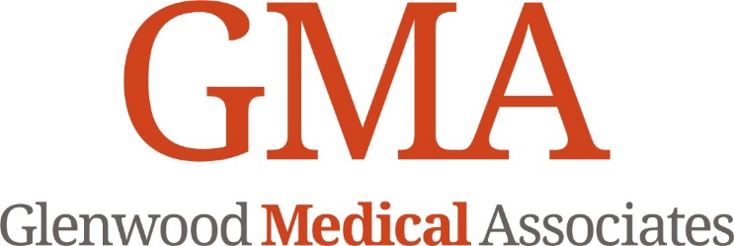

Advance Authorization for Treatment of a Minor

For families who are patients of Glenwood Medical Associates:

Although we encourage parental presence and participation at all healthcare visits for children, it may be necessary to have prior authorization for medical care delivered directly to minors without a parent or legal guardian present for urgent matters. Please review the following authorization for treatment and complete the information if you want to authorize such treatment for an urgent/acute visit only.

This is a one-time authorization for the date of service noted below.

AUTHORIZATION

I (we) request and authorize Glenwood Medical Associates (GMA) and its personnel to deliver medical care to my (our) child named below on ____________________.
(Date of service)

Minor’s Name (please print): __________________________________ DOB:________________

Authorizing Parent/Guardian Name (please print): _______________________________________

Signature:___________________________________________ Date:_____________________

Please try to contact me/us regarding the healthcare of my/our child at the following phone #s if you have any questions:

Parent's name (please print):__________________________________ Phone (office/home):_____________

Parent's name (please print):__________________________________ Phone (office/home):_____________

Other /Name (please print) :__________________________________ Phone (office/home):_____________
Relationship:________________________________

NOTE: If there are any special parental or custodial relationships (such as custody with one parent only, legal custody/guardianship with non-parent, etc.), please explain in the space below with your signature, printed name, and phone number at which you can be contacted.

